

COMSATS University Islamabad
(Attock Campus)

Information Security(Lab)
ASSIGNMENT # 01

Instructor: Miss. Amreen Gul
DATE: Sept 25, 2025

Submitted By:
Muhammad Talha Mehmood
SP24-BSE-041

Write python code for your designed stream cipher approach for encryption decryption, you can use approach from more than one already developed ciphers as given in lab practice exercises.

Code:
def gen_keyStream(key, length):

keyStream = ""
while len(keyStream) < length:
keyStream += key
return keyStream[:length]

def encrypt(plaintext, key):

keyStream = gen_keyStream(key, len(plaintext))
ciphertext = ""

for i in range(len(plaintext)):

ciphertext += chr(ord(plaintext[i]) ^ ord(keyStream[i]))
return ciphertext

def decrypt(ciphertext, key):

keyStream = gen_keyStream(key, len(ciphertext))
plaintext = ""

for i in range(len(ciphertext)):
plaintext += chr(ord(ciphertext[i]) ^ ord(keyStream[i]))
return plaintext

# Example usage
plaintext = input("Enter the plaintext: ")
key = input("Enter the key: ")
ciphertext = encrypt(plaintext, key)
print("Ciphertext:", ciphertext)
decrypted_text = decrypt(ciphertext, key)
print("Decrypted Text:", decrypted_text)

Screenshot:
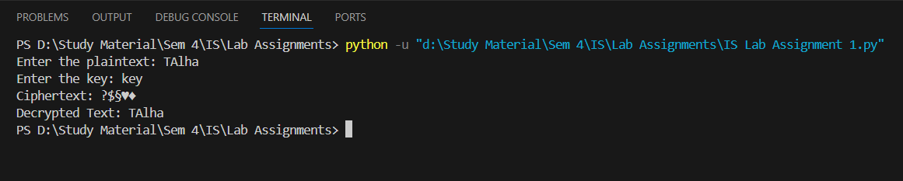

Design and implement an adversarial attack approach for your proposed stream cipher approach.
Code:
def recover_key_partial(known_plaintext, ciphertext):
recovered = ""
for i in range(len(known_plaintext)):
recovered += chr(ord(known_plaintext[i]) ^ ord(ciphertext[i]))
return recovered

def hex_to_ciphertext(hex_string):
bytes_object = bytes.fromhex(hex_string)
return bytes_object.decode('latin-1')

# Example usage for Part 2
known_plaintext = "HELLO"
ciphertext_hex = "1f0c0b0b0e"
ciphertext = hex_to_ciphertext(ciphertext_hex)
recovered_key = recover_key_partial(known_plaintext, ciphertext)
print("Recovered Key Segment:", recovered_key)

Screenshot:
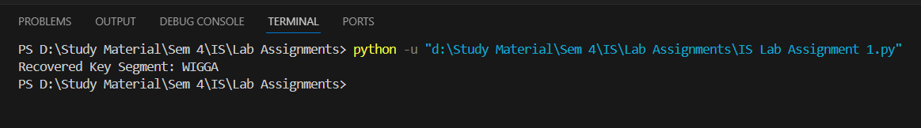
Explainaion:
This program has two parts. The first part builds a simple stream cipher: gen_keyStream repeats the user-entered key until it matches the message length and returns the slice [:length]; encrypt XORs each plaintext character with the corresponding keystream character (using ord/chr) to produce the ciphertext, and decrypt does the same XOR again to recover the original text (because XOR is reversible). The script asks the user for plaintext and key, prints the raw ciphertext (which may contain non-printable characters) and then prints the decrypted text to show the round trip. The second part demonstrates a basic known-plaintext attack: hex_to_ciphertext converts a hex string back into the program’s internal ciphertext form using bytes.fromhex(...).decode('latin-1') (latin-1 preserves raw byte values), and recover_key_partial XORs a known plaintext segment with the corresponding ciphertext bytes to reveal the keystream (a partial key) used there — illustrating how repeating a short key makes the cipher vulnerable.

